Intelligent Customer Churn Prediction & Retention Optimization System
Week 4: Machine Learning Model Development and Evaluation
Virtual Data Science with Python Apprentice Internship
Dataset: IBM Telco Customer Churn Dataset
Tools: Python, Pandas, NumPy, Scikit-learn, Matplotlib, Seaborn

1. Introduction
Week 4 focused on developing and evaluating a machine learning model for customer churn prediction. The objective was to transform the cleaned customer churn data into a format suitable for supervised learning, train a classification model, generate predictions for unseen test data, and evaluate performance using multiple metrics and visualizations. Logistic Regression was selected as the baseline model because the target variable is binary: a customer either stays with the company or churns.

2. Dataset and Data Preparation
The IBM Telco Customer Churn dataset contains customer demographic, service, contract, billing, and churn information. The dataset contained 7,043 customer records and 21 original variables. TotalCharges was converted from text to numeric form, and the blank values associated with new-customer records were handled as zero.
A separate working copy was created for machine learning. Churn was converted into binary values, where 0 represents customers who stayed and 1 represents customers who churned. CustomerID was removed because it is an identifier rather than a useful predictive feature. Categorical variables were converted into numerical representations using one-hot encoding.

3. Feature and Target Separation
The prepared dataset was divided into input features (X) and the target variable (y). Churn was used as the target because the purpose of the model is to predict whether a customer will churn. After preprocessing, the feature matrix contained 7,043 observations and 30 input features, while the target contained 7,043 observations.

4. Train-Test Split
An 80:20 train-test split was used. The training set contained 5,634 customers and the testing set contained 1,409 customers. Stratification was applied to preserve the proportion of churn and non-churn customers in both sets. A random state of 42 was used to make the split reproducible.

5. Feature Scaling
StandardScaler was applied to the numerical feature matrix before Logistic Regression training. The scaler was fitted using the training data and the same learned transformation was then applied to the testing data. This keeps the preprocessing consistent while avoiding information leakage from the test set.

6. Model Selection and Training
Logistic Regression was selected as the baseline classification algorithm because the task involves a binary outcome. It is relatively simple and interpretable and provides a useful baseline against which more complex models can later be compared. The model was trained on the scaled training features with max_iter set to 1,000.

7. Model Prediction
After training, the model was used to predict churn outcomes for the unseen testing data. Predictions were generated for all 1,409 test customers. Because the test data was not used during training, these predictions provide an assessment of model performance on unseen observations.

8. Model Evaluation Metrics
The model was evaluated using accuracy, precision, recall, F1-score, and ROC-AUC. Using multiple metrics is important because accuracy alone does not fully describe a churn classifier, particularly when the dataset contains more customers who stayed than customers who churned.
Metric | Result
Accuracy | 80.70%
Precision | 65.84%
Recall | 56.68%
F1-Score | 60.92%
ROC-AUC | 0.8418
The model achieved 80.70% accuracy overall. Precision was 65.84%, while recall was 56.68%. Recall is especially relevant for churn prediction because false-negative customers are actual churners who were not identified. The F1-score of 60.92% combines precision and recall. The ROC-AUC of 0.8418 indicates useful ability to distinguish between churn and non-churn cases.

9. Confusion Matrix
The confusion matrix gives a detailed view of correct and incorrect classifications. The resulting matrix was [[925, 110], [162, 212]].
 | Predicted Stayed | Predicted Churned
Actual Stayed | 925 | 110
Actual Churned | 162 | 212

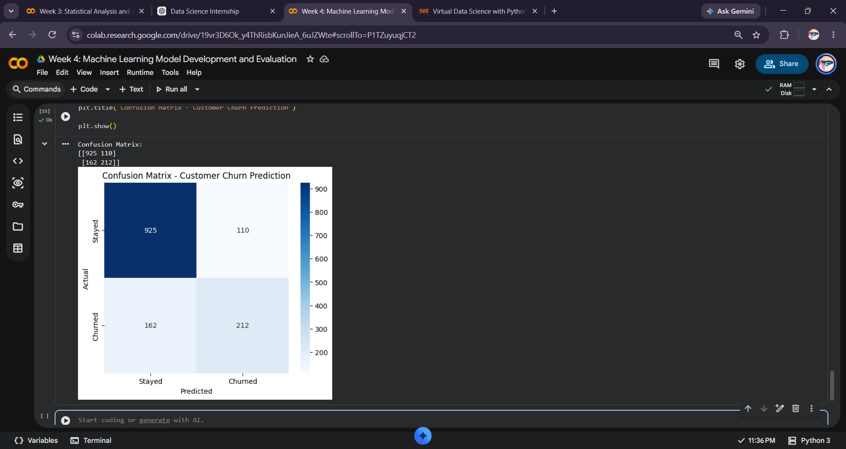
Figure 1. Confusion Matrix - Customer Churn Prediction
The model correctly classified 925 customers who stayed and 212 customers who churned. It incorrectly predicted 110 staying customers as churners and 162 actual churners as non-churners. The 162 false negatives are particularly important in a retention context because these customers could be missed by a churn-prevention strategy.

10. ROC Curve and AUC
The ROC curve evaluates the model's ability to distinguish between churned and non-churned customers across different classification thresholds. The calculated ROC-AUC was 0.8418.
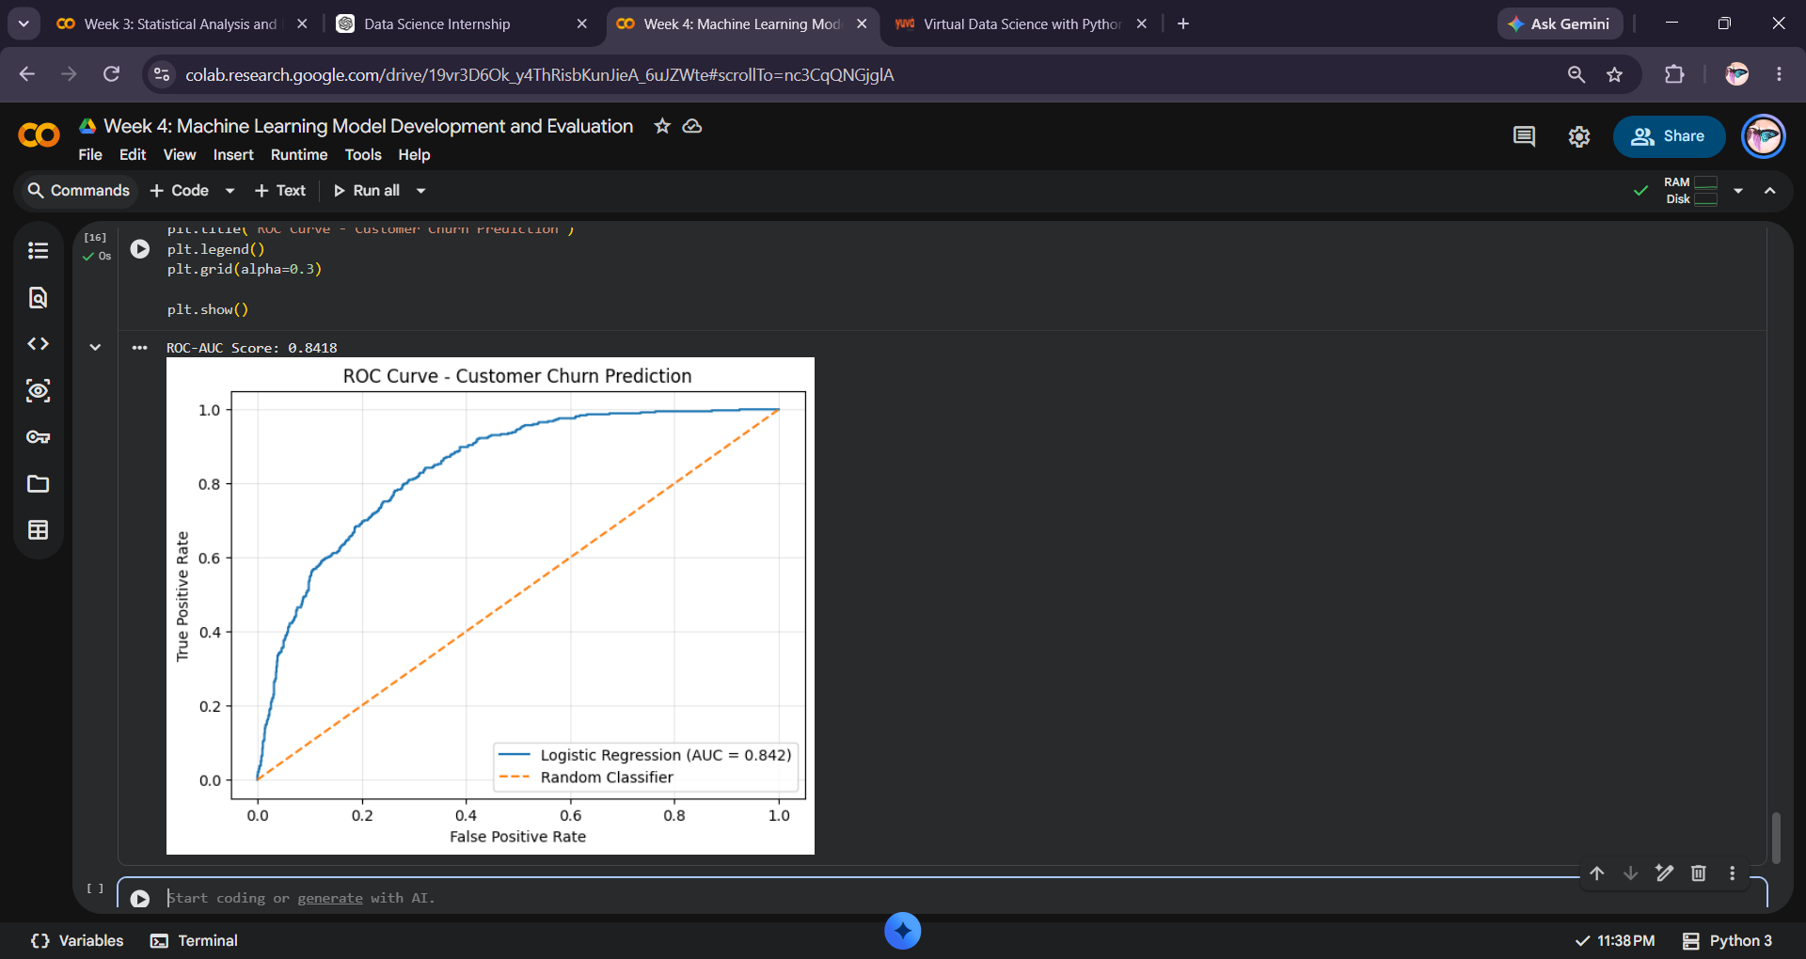
Figure 2. ROC Curve - Customer Churn Prediction
The ROC curve lies above the random-classifier reference line. An AUC of 0.8418 indicates useful discriminatory ability. However, ROC-AUC should be considered together with precision, recall, F1-score, and the confusion matrix.

11. Error Analysis and Model Limitations
The model made both false-positive and false-negative errors. The 162 false-negative cases show that some customers who actually churned were predicted to stay. The recall of 56.68% indicates that a substantial portion of actual churners were not detected at the default classification threshold.
Potential sources of error include overlapping characteristics between churned and non-churned customers, class imbalance, and the limitations of a basic linear classification model. Logistic Regression assumes a relatively simple relationship between the input variables and the probability of churn, so more complex patterns may not be captured.
Potential improvements include comparing Logistic Regression with Decision Tree, Random Forest, and Gradient Boosting models; performing feature engineering; tuning hyperparameters; using cross-validation; and evaluating suitable class-balancing approaches. Threshold tuning could also be investigated if detecting more potential churners is a priority.

12. Business Implications
The model provides a starting point for a customer-retention workflow. Customers identified as higher-risk could be reviewed for proactive engagement, service support, or targeted retention offers. Since this is a baseline model, predictions should be combined with business rules and additional customer information before operational decisions are made.

13. Conclusion
This Week 4 analysis established a complete machine-learning pipeline for customer churn prediction using the IBM Telco Customer Churn dataset. The workflow covered data preparation, categorical encoding, feature-target separation, an 80:20 train-test split, feature scaling, Logistic Regression training, prediction, and multi-metric evaluation.
The baseline model achieved 80.70% accuracy, 65.84% precision, 56.68% recall, 60.92% F1-score, and an ROC-AUC of 0.8418. The confusion matrix and ROC curve provided additional insight into model behavior beyond accuracy alone. The results show that machine learning can capture useful churn patterns while also highlighting opportunities for improvement.
Overall, Week 4 provides the machine-learning foundation for the Intelligent Customer Churn Prediction & Retention Optimization System. Future work can build on this baseline by comparing multiple models, improving features, tuning the decision threshold, and developing a more robust churn-risk prediction system.

14. Tools and Data Source
Programming language: Python
Libraries: Pandas, NumPy, Scikit-learn, Matplotlib, Seaborn
Environment: Google Colab
Dataset: IBM Telco Customer Churn Dataset
Source repository: IBM telco-customer-churn-on-icp4d

